

Year 12 ATAR Physics

Unit 3 Semester 1 2023

**Vectors, Inclined Planes and Projectile Motion Test**

Student Name: ______________________________

Assessment Date:

**TOTAL MARKS**

**/50**

Working time: 55 minutes

Weighting: 5%

Teacher Comments:

**You should answer ALL of the questions and show full working.**

**Express all numerical answers to three (3) significant figures unless it is an estimate or otherwise requested.**

**Question 1 (6 marks)**

A cyclist rides their bicycle North along a flat stretch of road at a constant velocity of 4.50 m s-1, doing work against a 60.0 N friction force. The combined mass of the cyclist and bicycle is 70.0 kg.

1. What is the net force acting upon the cyclist? Justify your response. [2]

1. The cyclist turns to the East with a new constant velocity of 3.50 m s-1. Find the change in velocity. Include a diagram. [4]

**Question 2 (3 marks)**

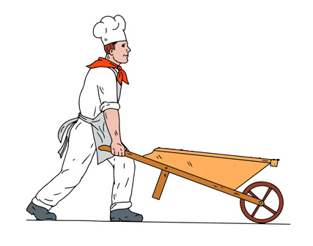A 20.0 kg wheelbarrow is being pushed at a constant velocity (by a chef… for reasons) such that the angle that the handle makes with the ground is 25˚. A horizontal friction force of 50.0 N opposes the motion of the wheelbarrow.

1. Find the force applied by the chef on the wheelbarrow. [2]

1. Find the force applied by the wheelbarrow on the chef. [1]

**Question 3 (4 marks)**

Starting from rest, an 85.0 kg skier slides down a snow-covered, frictionless slope. The slope makes an angle of 35.0o to the horizontal and has a length of 57.0 m.

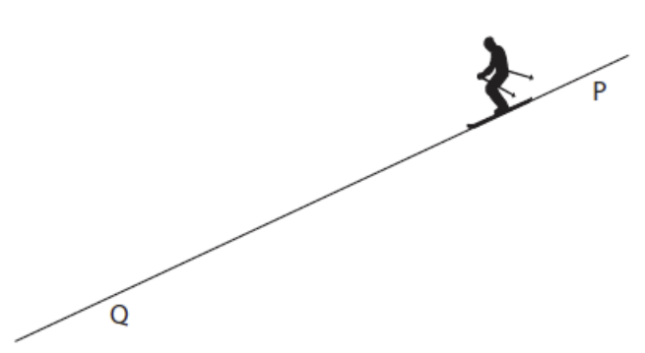

1. Given the skier starts at the top of the slope, calculate the time it would take for the skier to slide down the slope. [3]

|  |  |
| --- | --- |
| Fnet = mg sinθ  = 85 * 9.8 * sin (35)  = 478 N | 1 mark  Note – they may skip finding Fnet and equate  mg sinθ = ma, resulting in a = gsinθ. Full marks still awarded. |
| Fnet = m a  478 = 85 * a  a = 5.62 ms-2 | 1 mark |
| s = ut + ½ at2 , (given u = 0 m/s)  57 = 0.5 * 5.62 * t2  t = 4.50 s | 1 mark |

1. Calculate the velocity of the skier at the bottom of the slope. [1]

|  |  |
| --- | --- |
| v2 = u2 + 2as  = 2 * 5.62 * 57  v = 25.3 m/s  or  v = u + at  = 0 + 5.62 * 4.5  = 25.3 m/s (down the slope) | 1 mark |

**Question 4 (3 marks)**

An extreme sports BMX rider cycles horizontally off the edge of a 7.50 m high cliff face at an initial velocity of 7.50 ms-1.

1. Calculate the amount of time the rider will be in the air. [2]

|  |  |
| --- | --- |
| s = ut+ ½ at2  7.5 = 0.5 * 9.8 t2 | 1 mark |
| t = 1.24s | 1 mark |

1. Calculate how far from the base of the cliff the rider will land. [1]

|  |  |
| --- | --- |
| v = s / t  7.5 = s / 1.24  s = 9.30m (or 9.28m without rounding ‘t’) | 1 mark |

**Question 5 (6 marks)**

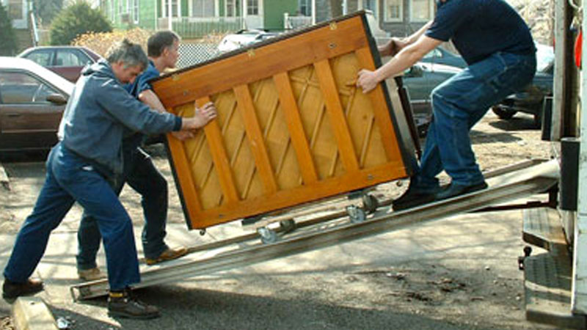Removalists need to load a 136 kg piano into a truck by placing it on a wheeled trolley and roll it up a ramp inclined at an angle of 22°. Ignore friction. The ramp will bend significantly if the normal reaction exerted by the ramp exceeds 1250 N.

1. Using calculations, determine whether the ramp will bend significantly (ignore the weight of the removalists). Include a free body diagram and a vector diagram in your answer. [4]

1. Calculate the minimum force up the ramp that must be exerted by the removalists to load the piano into the truck. [2]

**Question 6 (4 marks)**

Layla is practising her archery skills. The target is located 45.0 m away from her, at the same height as her firing position. The arrow is in flight for 0.72 s before it hits the target directly in the centre.

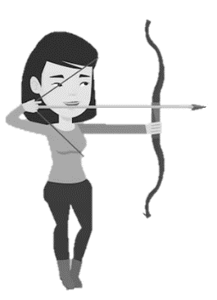 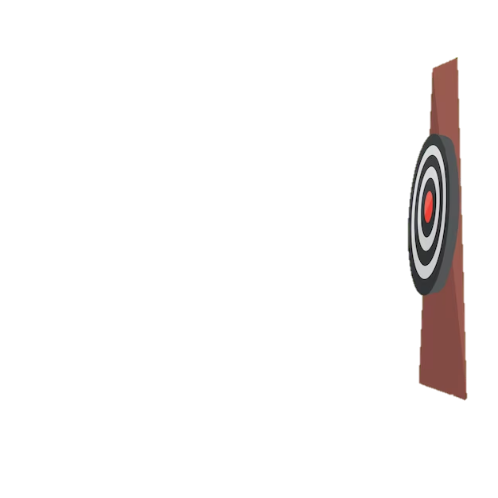

-

-

+

+

1. Ignoring air resistance, calculate the angle to the horizontal that the arrow was shot from.

|  |  |
| --- | --- |
| Calculates horizontal velocity  vh = s / t = 45 / 0.72 = 62.5 ms-1 | 1 mark |
| Calculates initial vertical velocity  s = ut+ ½ at2  0 = 0.72u + 0.5*(-9.8)*0.722 | 1 mark |
| u = 3.53 ms-1 (up) | 1 mark |
| Uses trig to solve for θ  Tan θ = 3.53 / 62.5  θ = 3.23 above the horizontal | 1 mark |

1. The fletching on her arrow came loose and added significant air resistance to her next shot. Describe how the angle would need to be adjusted to still hit the target (no calculation required). [1]

|  |  |
| --- | --- |
| Angle to the horizontal would need to increase | 1 mark |

**Question 7 (10 marks)**

Michael is watering the lawn and wants to estimate the initial velocity of the water coming from the hose.

1. Using the photograph (below) to make suitable estimates, calculate the magnitude of the initial velocity of the water. [5]

|  |  |
| --- | --- |
| Suitable estimate for vertical and horizontal displacement  Vertical: 1.3 to 1.5 m  Horizontal: 1.3 to 1.5 m | 2 marks |
| Calculates time of flight (using estimate of 1.5m)  s = ut+ ½ at2  1.4 = 0.5*9.8*t2  t = 0.534s  Expected answer between t = (0.515 – 0.553) s | 1 mark  Note: If initial estimates are outside acceptable range, allow follow-through marks for correct working. |
| Solves for horizontal velocity:  v = s / t = 1.4 / 0.534 = 2.62 m/s  Expected answer between v = (2.35 – 2.91) m/s | 1 mark |
| Reports with two sig figs:  2.4 m/s  Expected answer between (2.4 – 2.9) m/s | 1 mark |

1. Michael changes the setting on the tap which results in a new velocity of 3.80 ms-1. How far would the water land from Michael if the hose is held 1.20 m above the ground and pointed upwards at 40.0o to the horizontal. Include relevant vector diagrams in your answer. [5]

|  |  |
| --- | --- |
| Calculates initial velocities:  uh = 3.8 cos 40 = 2.91 m/s  uv = 3.8 sin 40 = 2.44 m/s  correct diagram  u  uv  40o  uh | 1 mark  1 mark |
| Substitutes to solve for t  Either quadratic formula or:  v2 = u2+ 2as = 2.442 + 2 * - 9.8 * -1.2  v = -5.43 m/s  v = u + at  -5.43 = 2.44 – 9.8t | 1 mark |
| Solves for t:  t = 0.803 s | 1 mark |
| s = 2.34 m | 1 mark |

**Question 8 (13 marks)**

A student tries to throw her ball over a tall fence. The ball is launched at an angle θ to the horizontal. The ball reaches its maximum height of 4.40 m above the ground, continues and then strikes the top of the fence at a horizontal distance of 5.20 m in front of her. The flight time from the launch position to striking the fence was 0.850 s.

Range = 5.20 m

Student launches ball from 1.70 m above ground

θ

u

Maximum height = 4.40 m

1. Calculate the initial velocity of the ball. Note that this is a vector quantity. [5]

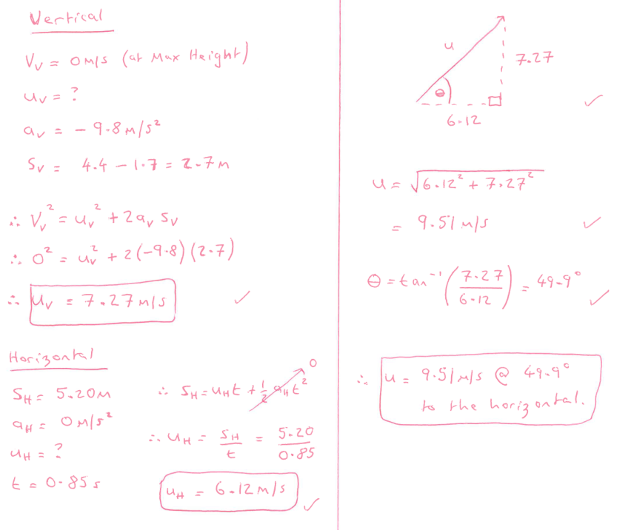

1. Calculate the height of the fence. If you did obtain an answer for (a), use a value of 9.50 m s-1 at 55.0° above the horizontal. [4]

1. The kinetic energy of the ball after 0.450 seconds of flight was 19.14 J. Calculate the mass of the ball. [4]

**END OF TEST**